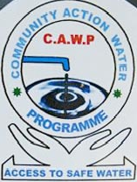
COMMUNITY ACTION WATER PROGRAMME
Juba - office

Hai Jebel Rock City; Tel: 0927352970, 0977108723, 0955178857; Web site: www.cawp-ss.org;

COMMUNITY ACTION WATER PROGRAMM EXECUTIVE DIRECTORS.

NAME TITLE

1- YONA LEMI EXECUTIVE DIRECTOR
2- VUKENI MOSES BOARD SECRETARY
3- VINCENT KUJO VICE CHAIRMAN
4- DAVIS YUMA BOARD TREASURER
5- MANDELA WANI BOARD MEMBER
6- Col. KANUTO EBEKE BOARD MEMBER
7- ASHA HAKIM ACCOUNTANT

ORGANIZATION PROFILE:

Company Name Community Action Water Programme
Offices website: www.cawp-ss.org
Uganda liaison office c/o 43 Koboko-Uganda
Telephone +256 476-422126/+256 782832467/+256 751832467

Juba Head office Hai Jebel Rock City opposite the market square

Kajo-Keji base Mere boma near Monobak PHC

Yei filed office Naviasha Guest House Juba road

Director Email yona.lemi@cawp-ss.org
lemiyona@yahoo.com
Mobiles +211 977107898
+211 955178857
Administrator Vukeni.moses@cawp-ss.org
raphlmoses@yahoo.ca
Mobiles +211 977108723
+211 927352970

Background:

Community Action Water Programme (CAWP) is a national organization with its head office in Juba Hai Jebel Rock City, base/field office Kajo – Keji County opposite Mere PHCU, branches offices in Yei County and Liaison office in Koboko – Uganda.

Community Action Water Programme was established in 2006.in Kajo-keji County. It was registered with SSRRC on 2 /6/2006 under section 11.2 of the new Sudan ACT 1999 and on the 15th January 2007, registered by Ministry of Cooperative and Rural Development (MCRD) in Juba and renewed on 10 March, 2008 with SSRRC and. On 5th August 2009 registered, by Ministry of Legal Affairs and Constitutional Development and licences by Ministry of Water Resources and Irrigation.

The organization was created to answer for the millennium development goal (MDGs) that target to Halve by 2015 proportion of people in Southern Sudan with access to potable water as a result of great demand CAWP was established as part of the solution to attain the MDGs to carry out the following tasks-
Increase access to safe potable water through the following activities-
- Drilling/ Construction of deep boreholes and mounted with hand pump.
- Rehabilitation / Repair of existing water points.
- Hand dug wells Construction.
- Protection of springs.
- Carry out Capacity building of water management committees of the water beneficiaries.
- Carry out integrated water management system such as mini water yard, roof water harvest and free gravity system.
- Construction of sanitary facility in the schools and pubic places.
- Conduct Community awareness on hygiene and sanitation as a way of combating poverty, improving live hood, reducing mortality rate and minimizing water borne diseases.

VISION:
Safe water for the needed people

MISSION STATEMENT:
Promote hygiene and healthy environment through provision of safe portable water

The primary objectives are-
The primary objectives are to help people (in where and beyond) by-
- Provision of potable water or assistance to the host population and the returnees to alleviate the poor standard of living among the communities.
- Undertaking Advocacy on behalf of the people generally women, children, the disadvantaged and returnees.
- Promoting self reliance and minimizing dependency brought about by years of relief assistance.
- Mobilizing financial materials, and other forms of support from the institutions, individual, the government, and partners.

Project Management.
The Organization has a board of seven (7) members who have experiences both in relief and development activities with International Aid Services (IAS) and other Organizations in the South Sudan.
The management of Community Action Water Programme (CAWP) is undertaken by the Executive Director who has over thirty (35) years’ experiences in the field of water development system and water sources management, both in Sudan and Uganda with the following Organizations.-

From 1977 to 1983 on secondment by Ministry of Cooperatives Rural water Development to Norwegian Church Aid Torit.
1983 to 1984 UNICEF Wau.
1984 to 1986 UNICEF Yambio.
1987 to 19989 UNHCR/SFM/RWD Yei.
1990 to 1993 Joint SPLA and commission as an officer and became sector Head for water in the SPLM Control areas.
In 1994 seconded to IAS both Sudan and Uganda Programme. To run the water and sanitation in Southern Sudan liberated areas.
2006 created Community Action Water Program (CAWP) and a member of drillers club Atlas Capo Sweden given a recognition by CHARLES HIROES AS DRILLER for water for all having carried out drilling of more than 1000 boreholes for the needed people in the world and training of different cadres involving in virtually every aspect of the process including spring protection , well digging , drilling of deep boreholes ,general maintenance of machineries ,training of water technicians and the overall management.

The project has been supported by the following staff:
- Executive Director
- Administrator
- Financial officer.
- Store Keeper/Logistician.
- statistics clerk
- Field supervisors.
- Community Development officer (CDO)
- Drivers
- Cleaner/Cooks
- Security Guards.

The past performance of CAWP Work since it started it works in 2006

No | Type of contract | Name of client | USD value | Duration | Location where work performed | Description of type of work
1 | Water and sanitation | IAS/ Danida | 320,000 | 3 years 2006-2008 | Kajo keji County | Drilling of 50 new boreholes
2 | Drilling | DRC | 72,000 | 2007-2008 | KAJO KEJI | Drilling of 8 boreholes
3 | Drilling | Pact Sudan/ DRC | 90,000 | 6 month 2008 | Lainya County | Drilling of 10 boreholes
4 | Drilling | IAS/SIDA | 128,000 | 2008 | PADER-Uganda | Drilling of 16 boreholes
5 | Drilling | SPC | 24,000 | 2008 | Yei County | Drilling of 3 boreholes
6 | Drilling | SUHA | 90,000 | 2008 | Lainya/Yei Counties | Drilling new boreholes 3 in Lainya and 6 in Yei counties
7 | Drilling | ECS | 54,000 | 2008-2009 | Kajokeji County | Drilling of 7 boreholes
8 | Drilling | GTZ | 27,000 | 2008 | Morobo County | Drilling of 3 boreholes
9 | Drilling | DRC | 45,000 | 2008 | Yei county | Drilling of 5 boreholes
10 | Drilling and IWRM | IAS/DANIDA | 320,030 | 2009-2010 | KAJOKEJI County | Drilling of 30 new borehole, 30 rehab, construction of 3mini water yards
11 | Drilling | SUHA | 40,000 | 2011 | Lainya County | Drilling of 4 boreholes
12 | Drilling | SUHA | 60,000 | 2011 | Yei County | 6 borehole drilling
13 | Drilling | UMC | 27,570 | 2011 | Yei County | 3 boreholes drilling
14 | Drilling | I. O. M | 41,534 | 2011 | Lainya County | 4 boreholes drilling
15 | Drilling | I.O.M | 20,850 | 2011 | Lainya County | 10 boreholes rehabilited
16 | Drilling | CES | 54,900ssp | 2011 | Juba County | 2 boreholes drilling
17 | Drilling | CES | 54,900ssp | 2011 | Terekaka County | 2 boreholes drilling
18 | Spring protection | Giz | 22,800ssp | 2011 | Morobo County | Protection of 4 springs
19 | Drilling | IOM | $120,000 | 2011 | Yambio WES | Drilling of 10 boreholes
20 | Drilling | Lively-hood under MAF | $ 150,000 | 2011 - 2012 | Magwi County EES | Drilling of 11 boreholes
21 | Drilling | ZOA | $ 68,000 | 2011 – 2012 | Yei and Lainya Counties CES | Drilling of new boreholes and rehabilitation of old broken water points
22 | Rehabilitation | Danish Church | $ 6,300 | 2012 | Lainya County CES | Modification of old hand dug well into hands Pump

FACILITIES AND EQUIPMENTS.
No. | DESCRIPTION | Capacity | OWNED BY
1 | Pat-Drill 301 TP With progressive pump | 100 meter | CAWP
2 | Compressor 186 model | 12 bar | CAWP
3 | Atlas COPCO Aqua drill rig 500 | 250 meters | CAWP
4 | Compressor XHRVS 455 MODEL | 40 bars | CAWP
5 | Borehole development compressor wit TA-80 Diesel 10 HP- Unit | 10 HP | CAWP
6 | Deep meter | 100 meter cable | CAWP
7 | Pump test unit | 5000 L/Hrs | CAWP
8 | Generator for pumping test | 5 KVS | CAWP
9 | Tetrameter 1000 for geophysical survey | set | CAWP
10 | Laboratory for water quality test | Complete | IAS/CAWP Partners
11 | 4x4 wheel driver land cruiser | Picks (02) | CAWP
12 | 4 x4 WD Land Cruiser Station | 13 seats (01) | CAWP
12 | M/benz 4x4 drive mounted with Rig | 7 tons (01) | CAWP
13 | IVECO Mugrius Trucks | 8 tons (02) | CAWP

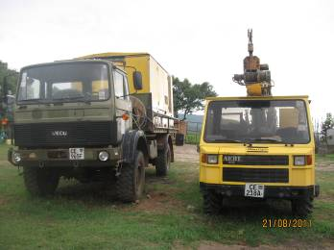
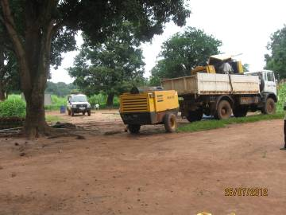

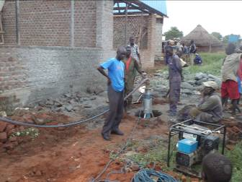
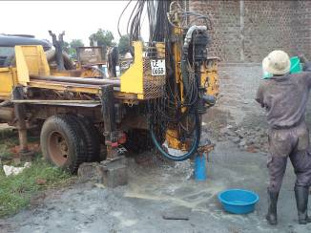

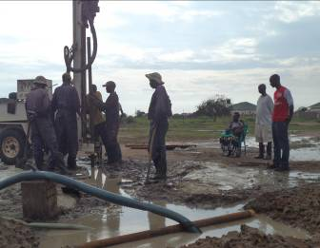
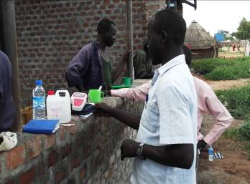

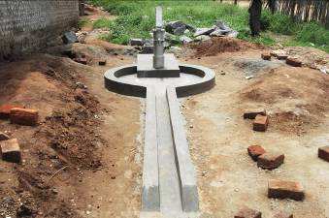
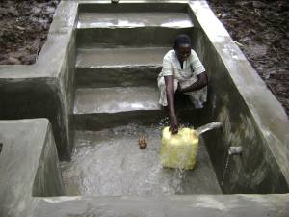

CAMPANY PROFESSIONAL STAFF

No. | Title | Name | Qualification | Years of experiences
1 | Director | Lemi Yona | Water Engineer See attached | 33 years
2 | Project Manager | Vukeni Moses | Advance Diploma in Business and administration & BA in BFA CIC London | 13 years
3 | Drilling supervisor | Alfred Luga | Completed Loka secondary school | 15 years
4 | Driller | Lawrence Moro | Completed A level in Uganda | 10 years
5 | Pump technician | Tombek John | Lirya primary certificate | 18 years
6 | Mechanic | Jimmy Cater | Completed Loka intermediate | 8 years
7 | Senior hydrgelogist | Moses Joseph | Degree Juba university in Khartoum | 5 years
8 | Water annalist technician | Taban James | Lab technician advance level in Uganda | 10 years

COMMUNITY ACTION WATER PROGRAMME (CAWPO)

ORGANIZATIONAL PROFILE

